Edge of a Solid
# Source: AI Source: Provided by: [Data Path: Persons Table -> ID Column: 1, Name_En Column: Motasem Essam] -> From: [ChatGPT] on [7/25/2026]
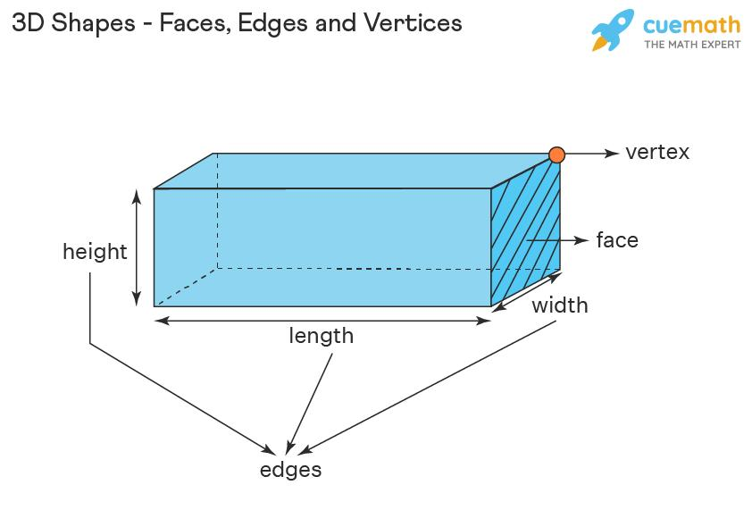
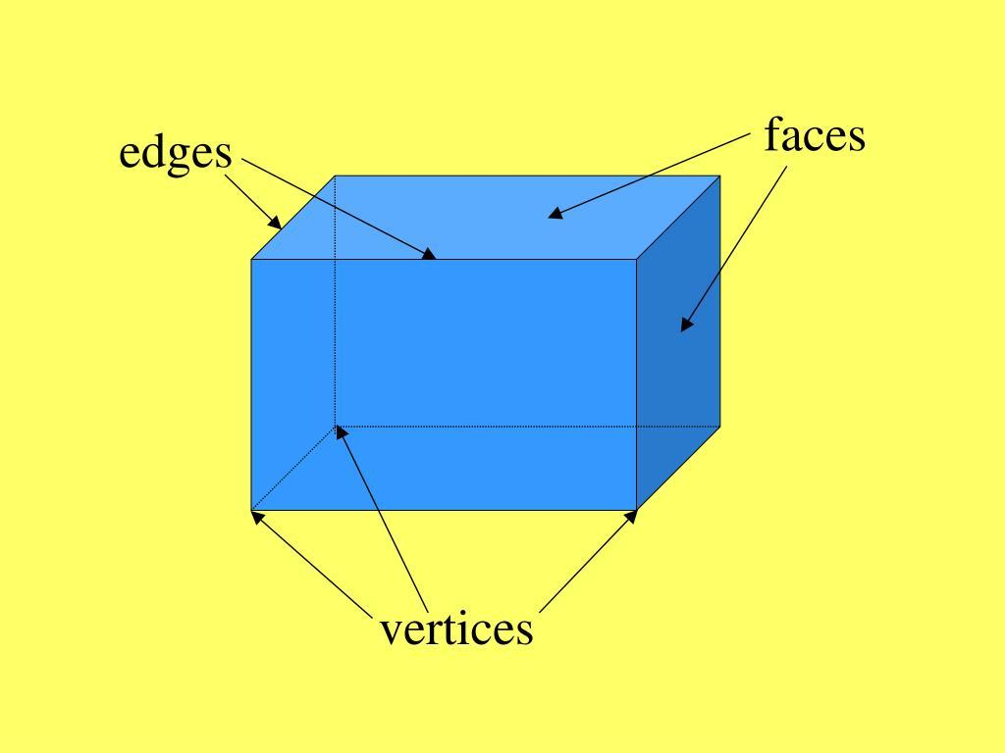
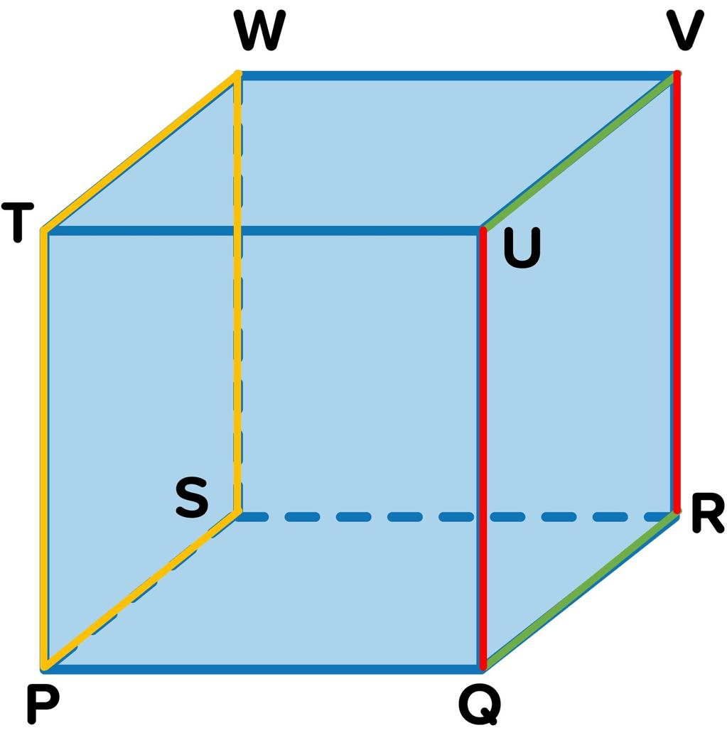

Definition
# Source: AI Source: Provided by: [Data Path: Persons Table -> ID Column: 1, Name_En Column: Motasem Essam] -> From: [ChatGPT] on [7/25/2026]
An edge of a solid is a line segment that forms part of the boundary of a three-dimensional geometric object. In a polyhedron, an edge is the straight segment where two faces meet, joining two vertices.
For example, a cube has 12 edges. Each edge connects two adjacent vertices and forms part of the boundary of two neighboring square faces.
Edges are important in solid geometry because they define the structure of polyhedra, determine how faces connect, and help describe a solid's dimensions.

Simple Definition
# Source: AI Source: Provided by: [Data Path: Persons Table -> ID Column: 1, Name_En Column: Motasem Essam] -> From: [ChatGPT] on [7/25/2026]
An edge is a straight line segment along the boundary of a solid, usually where two flat faces meet.
Examples include:
- The straight boundaries of a cube.
- The long and short boundaries of a rectangular prism.
- The sloping segments connecting the base vertices to the apex of a pyramid.
Important distinction: An edge is a finite line segment, not an infinite straight line. For a polyhedron, each edge has two endpoints called vertices.

Key Characteristics of an Edge
# Source: AI Source: Provided by: [Data Path: Persons Table -> ID Column: 1, Name_En Column: Motasem Essam] -> From: [ChatGPT] on [7/25/2026]
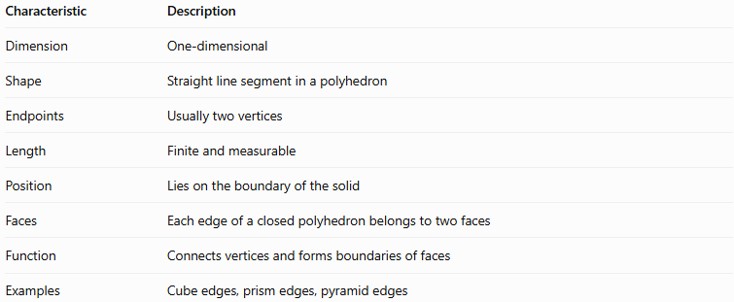
Characteristic | Description
Dimension | One-dimensional
Shape | Straight line segment in a polyhedron
Endpoints | Usually two vertices
Length | Finite and measurable
Position | Lies on the boundary of the solid
Faces | Each edge of a closed polyhedron belongs to two faces
Function | Connects vertices and forms boundaries of faces
Examples | Cube edges, prism edges, pyramid edges

Types of Edges in Solid Geometry

A. Base Edges
# Source: AI Source: Provided by: [Data Path: Persons Table -> ID Column: 1, Name_En Column: Motasem Essam] -> From: [ChatGPT] on [7/25/2026]
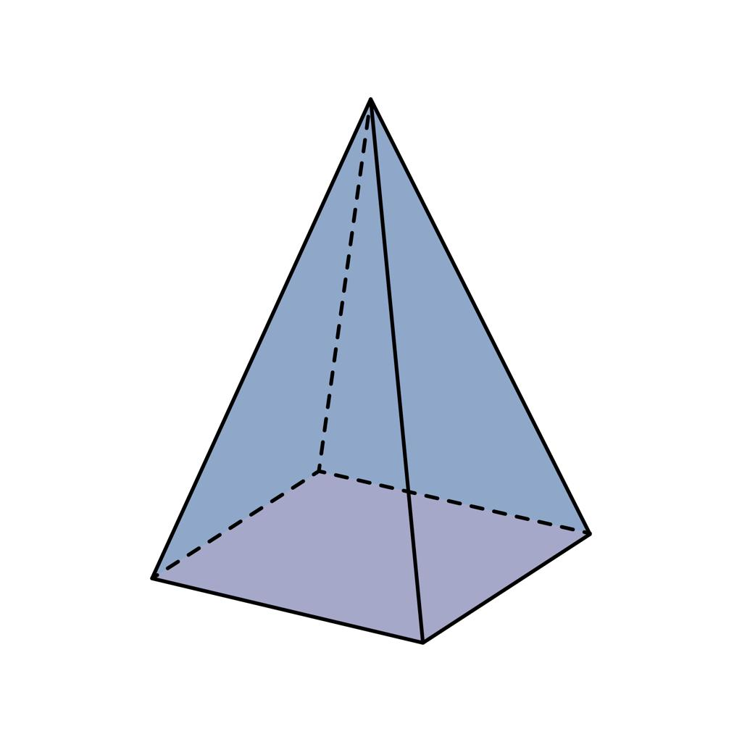
Base edges are the edges that form the boundary of a solid's base face.
Examples:
- A cube's bottom four edges.
- The three edges around the triangular base of a triangular prism.
- The four edges around the square base of a square pyramid.
A solid may have one or more base faces, depending on its type.

B. Lateral Edges
# Source: AI Source: Provided by: [Data Path: Persons Table -> ID Column: 1, Name_En Column: Motasem Essam] -> From: [ChatGPT] on [7/25/2026]
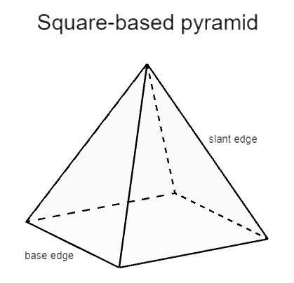
Lateral edges connect the base of a solid to another part of its structure.
- In a pyramid, each lateral edge connects a base vertex to the apex.
- In a prism, lateral edges connect corresponding vertices of its two bases.
For a right prism, the lateral edges are perpendicular to the base planes. For an oblique prism, they are inclined.

C. Vertical Edges
# Source: AI Source: Provided by: [Data Path: Persons Table -> ID Column: 1, Name_En Column: Motasem Essam] -> From: [ChatGPT] on [7/25/2026]
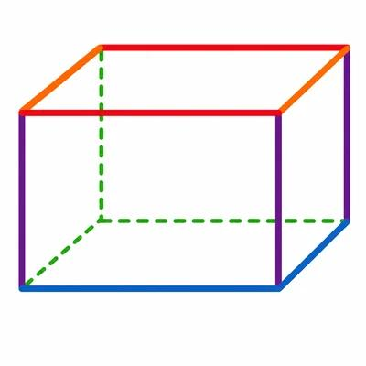
Vertical edges are edges that run vertically in a chosen orientation of the solid.
For a standard upright cuboid, the four vertical edges connect the corresponding vertices of the top and bottom faces.
Vertical is a positional description, not a separate fundamental kind of geometric edge: rotating the solid can change which edges appear vertical.

D. Horizontal Edges
# Source: AI Source: Provided by: [Data Path: Persons Table -> ID Column: 1, Name_En Column: Motasem Essam] -> From: [ChatGPT] on [7/25/2026]
Horizontal edges run horizontally in a chosen orientation.
For an upright cuboid, the edges around the top and bottom faces are horizontal. Some are parallel to the length, while others are parallel to the width.

E. Sloping Edges
# Source: AI Source: Provided by: [Data Path: Persons Table -> ID Column: 1, Name_En Column: Motasem Essam] -> From: [ChatGPT] on [7/25/2026]
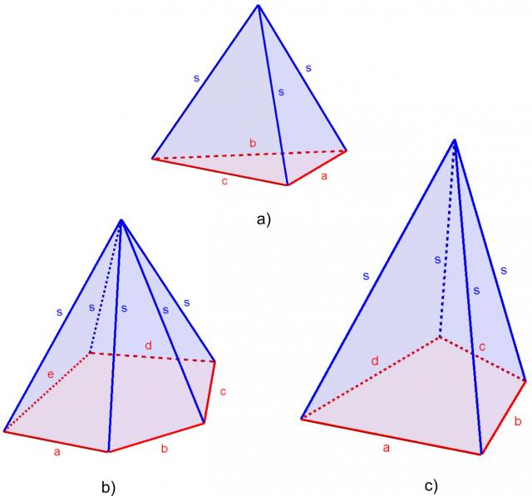
Sloping edges are inclined relative to a chosen horizontal or vertical direction.
Examples include the lateral edges of an oblique prism and the sloping edges connecting the apex of a pyramid to its base vertices.

F. Curved Boundaries of Solids with Curved Surfaces
# Source: AI Source: Provided by: [Data Path: Persons Table -> ID Column: 1, Name_En Column: Motasem Essam] -> From: [ChatGPT] on [7/25/2026]
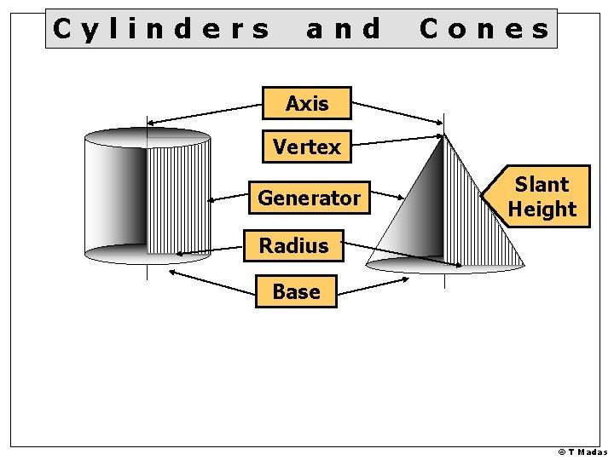
Cylinders and cones have circular boundaries where flat bases meet curved surfaces. These are often informally called curved edges.
However, in the strict polyhedral definition, an edge is a straight line segment shared by two polygonal faces. A circle is not a straight line segment, so the circular rim of a cylinder is not a polyhedral edge.

Number of Edges in Common Solids
# Source: AI Source: Provided by: [Data Path: Persons Table -> ID Column: 1, Name_En Column: Motasem Essam] -> From: [ChatGPT] on [7/25/2026]
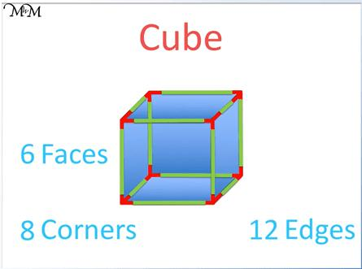
Cube
- Vertices: 8
- Edges: 12
- Faces: 6
Every edge has length $a$, where $a$ is the cube's side length.
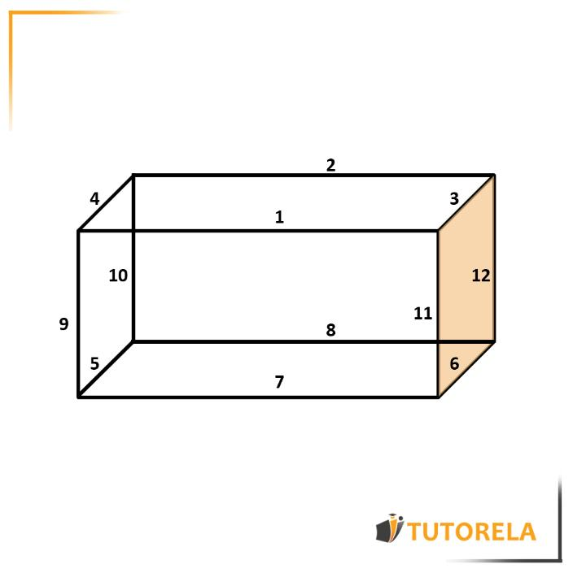
Rectangular prism (cuboid)
- Vertices: 8
- Edges: 12
- Faces: 6
Four edges have length $l$, four have length $w$, and four have length $h$.
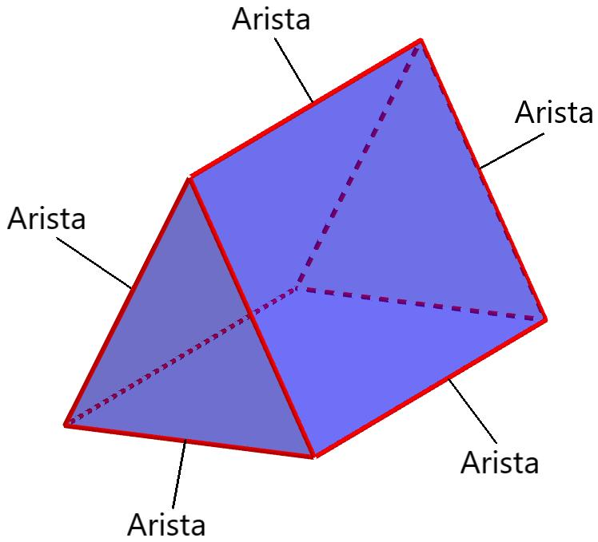
Triangular prism
- Vertices: 6
- Edges: 9
- Faces: 5
It has six edges around its triangular bases and three lateral edges.
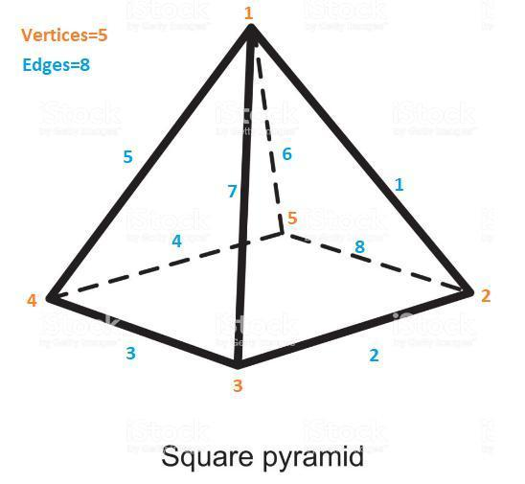
Square pyramid
- Vertices: 5
- Edges: 8
- Faces: 5
It has four base edges and four lateral edges.
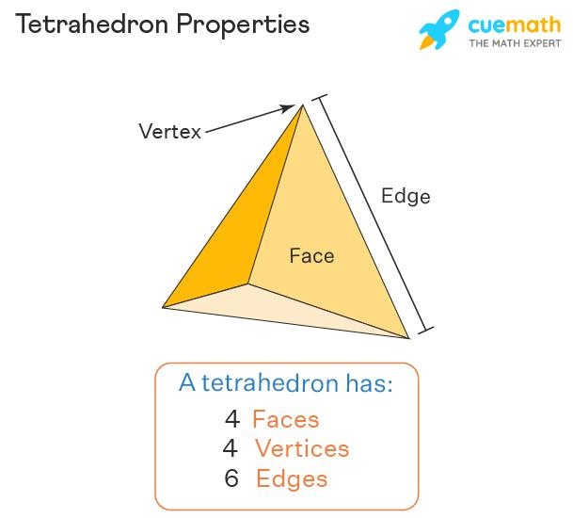
Triangular pyramid (tetrahedron)
- Vertices: 4
- Edges: 6
- Faces: 4
Every pair of vertices is connected by an edge.

7. Mathematical Representation of an Edge
# Source: AI Source: Provided by: [Data Path: Persons Table -> ID Column: 1, Name_En Column: Motasem Essam] -> From: [ChatGPT] on [7/25/2026]
An edge can be represented as a line segment between two vertices.
Let the endpoints be
$$A=\left(x_{1},y_{1},z_{1}\right), B=\left(x_{2},y_{2},z_{2}\right)$$
The length of edge $AB$ is
$$\boxed{\left|AB\right|=\sqrt{{\left(x_{2}-x_{1}\right)}^{2}+{\left(y_{2}-y_{1}\right)}^{2}+{\left(z_{2}-z_{1}\right)}^{2}}}$$
Example: Finding the length of a 3D edge
Suppose the endpoints of an edge are
$$A=\left(1,2,3\right), B=\left(4,6,3\right)$$
Substitute into the distance formula:
$$\left|AB\right|=\sqrt{{\left(4-1\right)}^{2}+{\left(6-2\right)}^{2}+{\left(3-3\right)}^{2}}$$
$$=\sqrt{9+16+0}=\sqrt{25}$$
$$\boxed{\left|AB\right|=5\text{ units}}$$
Therefore, the edge has a length of 5 units.

Total Length of All Edges
# Source: AI Source: Provided by: [Data Path: Persons Table -> ID Column: 1, Name_En Column: Motasem Essam] -> From: [ChatGPT] on [7/25/2026]
The total edge length of a polyhedron is the sum of the lengths of all its edges.
Cube
For a cube with side length $a$, there are 12 equal edges:
$$\boxed{L_{\text{total}}=12a}$$
If $a=4\text{ cm}$,
$$L_{\text{total}}=12\left(4\right)=48\text{ cm}$$
Rectangular prism
For a cuboid with length $l$, width $w$, and height $h$, there are four edges of each dimension:
$$\boxed{L_{\text{total}}=4\left(l+w+h\right)}$$
For $l=5\text{ cm}$, $w=3\text{ cm}$, and $h=2\text{ cm}$,
$$L_{\text{total}}=4\left(5+3+2\right)$$
$$\boxed{L_{\text{total}}=40\text{ cm}}$$

Relationship Between Edges, Vertices, and Faces
# Source: AI Source: Provided by: [Data Path: Persons Table -> ID Column: 1, Name_En Column: Motasem Essam] -> From: [ChatGPT] on [7/25/2026]
For a convex polyhedron, Euler's formula connects the number of vertices, edges, and faces:
$$\boxed{V-E+F=2}$$
where:
- $V$ = number of vertices
- $E$ = number of edges
- $F$ = number of faces
Rearranging gives
$$\boxed{E=V+F-2}$$
Example: A cube has $V=8$ vertices and $F=6$ faces.
$$E=8+6-2$$
$$\boxed{E=12}$$
This confirms that a cube has 12 edges.

Edge vs. Vertex vs. Face
# Source: AI Source: Provided by: [Data Path: Persons Table -> ID Column: 1, Name_En Column: Motasem Essam] -> From: [ChatGPT] on [7/25/2026]
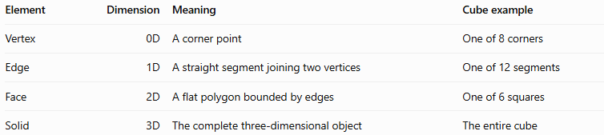
Element | Dimension | Meaning | Cube example
Vertex | 0D | A corner point | One of 8 corners
Edge | 1D | A straight segment joining two vertices | One of 12 segments
Face | 2D | A flat polygon bounded by edges | One of 6 squares
Solid | 3D | The complete three-dimensional object | The entire cube
These elements work together to define the structure of a polyhedron: vertices mark corners, edges connect those corners, and faces enclose the surface.

Applications of Edges in Solid Geometry
# Source: AI Source: Provided by: [Data Path: Persons Table -> ID Column: 1, Name_En Column: Motasem Essam] -> From: [ChatGPT] on [7/25/2026]
Edges are used in:
- Architecture: Measuring the boundaries of building components and frames.
- Engineering: Defining the dimensions and connections of mechanical parts.
- 3D modeling: Constructing polygon meshes from vertices, edges, and faces.
- Packaging: Designing boxes, cartons, and other polyhedral containers.
- Mathematics: Calculating edge lengths, counting structural elements, and applying Euler's formula.

Key Points
# Source: AI Source: Provided by: [Data Path: Persons Table -> ID Column: 1, Name_En Column: Motasem Essam] -> From: [ChatGPT] on [7/25/2026]
- An edge of a polyhedron is a straight line segment connecting two vertices.
- Each edge of a closed polyhedron belongs to exactly two faces.
- Base, lateral, vertical, horizontal, and sloping describe different roles or orientations of edges.
- A cube and a cuboid each have 12 edges.
- The 3D distance formula calculates the length of an edge from its endpoints.
- Euler's formula relates the numbers of vertices, edges, and faces for convex polyhedra.
- Circular rims on cylinders and cones are curved boundaries, not straight polyhedral edges.

Conclusion
# Source: AI Source: Provided by: [Data Path: Persons Table -> ID Column: 1, Name_En Column: Motasem Essam] -> From: [ChatGPT] on [7/25/2026]
An edge is a fundamental structural element of a solid, connecting vertices and forming the boundaries of its faces. Understanding the different types of edges, their lengths, and their relationships with faces and vertices makes it easier to analyze and describe three-dimensional objects.

